BIM-compliant 3D models offer outstanding potential in 2016
Dishwashing machine manufacturer Meiko offers innovative service

Intelligent warewashing technology for the commercial sector, outstanding service, and superb problem-solving capabilities for wash-up areas in hotels, restaurants, and canteens – these are the key selling points which have prompted such international renown for the company Meiko Maschinenbau GmbH & Co. KG, which is based in Baden-Württemberg, Germany. Now the company has introduced another exciting innovation – and this time it’s not a new product, but an innovative service specially designed for commercial kitchen planners and architects. “We’re delighted to be able to offer state-of-the-art support in the field of building information modelling systems to our partners in the planning sector in the form of the 3D application M-iPlan, which was designed and developed in-house by Meiko“, says Dr.-Ing. Thomas Peukert, Executive Vice President Research and Development.

Ever since early December 2015, commercial kitchen planners have been able to use Meiko’s online configurator to provide their customers with 3D models which comply with building information modelling (BIM) requirements, providing the perfect visualisation of plans for the wash-up areas of commercial kitchens. As the company announced in a press release, these BIM-compliant 3D models specifically tailored to commercial warewashing systems are currently only commercially available from Meiko.

M-iPlan is one of the industry solutions developed in-house by Meiko, whose planning department carried out the technical adaptations for the 3D application. “M-iPlan not only provides planners with a tool that makes their work easier, but also fulfils a market requirement in the field of commercial warewashing systems which also benefits end customers by allowing them to see at a glance exactly what they’re buying,” says Jürgen Walter, who heads up the planning department at Meiko. The application has been available to Meiko partners from the Meiko website’s download area since March 2016 – at no charge.

“As you would expect from a BIM-compliant solution, we have also provided the 3D models with technical information which can easily be controlled using the mouse,” explains Thomas Peukert. The technical details provided in parallel by Meiko should make planning firms’ work even easier. “Meiko is a trusted partner who provides solutions for all aspects of the work involved in designing and planning wash-up areas. And that doesn’t just apply to the people who use our products, but also to our partners at planning and architects’ firms. We could never have achieved our decades of success in this market without their assistance, and we have always strived to maintain close ties which have only grown stronger over the years,” says Peukert.

Caption

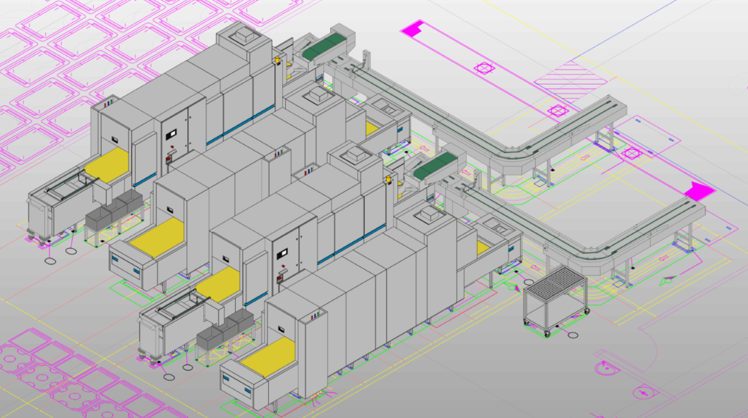

MEIKO has the solution – its 3-D application M-iPlan provides outstanding support for specialist planners and architects!

